Tabari Harvey Module 1.2 Assignment

1. 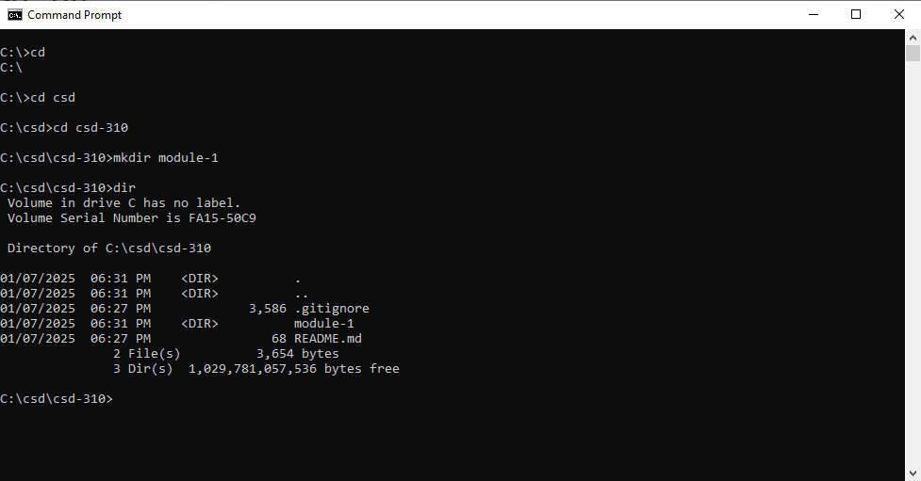 Module 1